Reverse Warning Chime – CGEA1.3

Functional Description

The Reverse Warning Chime feature warns the driver that the vehicle's transmission is in the reverse gear. The Reverse Warning Feature interacts with the Chime Arbitrator. This feature shall only be active for the Japanese market.

Interfaces

Interface Context Diagram (I/O Block Diagram)

- Reverse Warning Chime Context Diagram

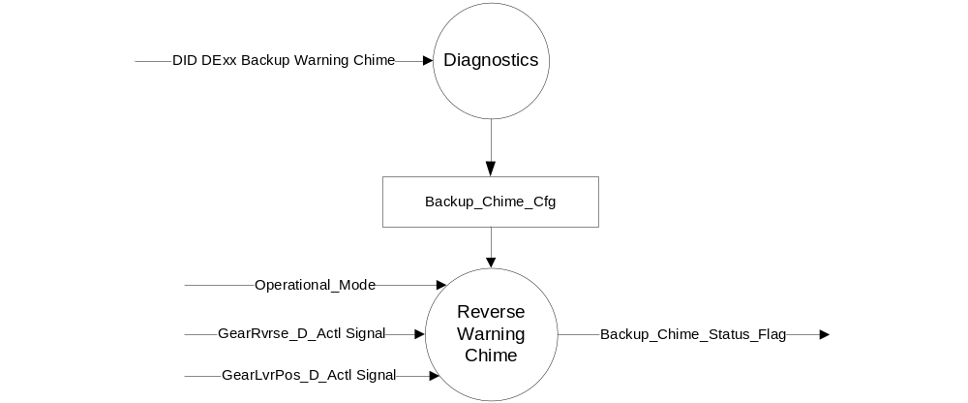

Input

- INTERNAL:
- Operational Modes: refer to section Operational Modes
- Backup_ Chime_Cfg

- MUX message on the CAN Bus

Table 1.0 GearLvrPos_D_Actl Signal

Signal Name | Size (bits) | Detail | Units | Res. | Offset | State Encoded | Min | Max
GearLvrPos_D_Actl | 4 |  | SED | 1 | 0 |  | 0 (0x0) | 15 (0xF)
 |  | Park |  |  |  | 0x0
 |  | Reverse |  |  |  | 0x1
 |  | Neutral |  |  |  | 0x2
 |  | Drive |  |  |  | 0x3
 |  | Sport_DriveSport |  |  |  | 0x4
 |  | Low |  |  |  | 0x5
 |  | first |  |  |  | 0x6
 |  | second |  |  |  | 0x7
 |  | third |  |  |  | 0x8
 |  | fourth |  |  |  | 0x9
 |  | fifth |  |  |  | 0xA
 |  | sixth |  |  |  | 0xB
 |  | Undefined_Treat_as_Fault |  |  |  | 0xC
 |  | Undefined_Treat_as_Fault |  |  |  | 0xD
 |  | Unknown_Position |  |  |  | 0xE
 |  | Fault |  |  |  | 0xF

Table Error! Use the Home tab to apply 1.1 to the text that you want to appear here..1 GearRvrse_D_Actl Signal (for variants with Manual Trans)

Signal Name | Size (bits) | Detail | Units | Res. | Offset | State Encoded | Min | Max
GearRvrse_D_Actl | 3 |  | SED | 1 | 0 |  | 0  (0x0) | 7  (0x7)
 |  | Inactive_not_confirmed |  |  |  | 0x0
 |  | Inactive_confirmed |  |  |  | 0x1
 |  | Active_not_confirmed |  |  |  | 0x2
 |  | Active_confirmed |  |  |  | 0x3
 |  | NotUsed_1 |  |  |  | 0x4
 |  | NotUsed_2 |  |  |  | 0x5
 |  | NotUsed_3 |  |  |  | 0x6
 |  | Fault |  |  |  | 0x7

Outputs
- INTERNAL:

- Backup_Chime_Status_Flag: Internal flag to the Chime Arbitrator.

Function/Performance

Operational Modes

Mode | Differentiating Vehicle Conditions
Sleep Mode | Reverse Warning Chime OFF
Limiting Mode | Reverse Warning Chime OFF
Normal Mode | Reverse Warning Chime ON - OFF
Crank Mode | Reverse Warning Chime OFF

Voltage Levels

Refer to Cluster Features Table located in the Operational Modes and Voltage Range Strategies Section in this SPSS.

Human-Machine Interface

Visual

None

Audio

Refer to the Chimes & Chime Arbitrator SPSS section

Switch Control Logic

Not Applicable.

System Accuracy

- The state of this chime flag shall change within 100 msec of a state change as indicated in the state matrix found in section 1.3.5.1 of this document
- Refer to System Accuracy in Chimes & Chime Arbitrator SPSS Section

Operation: Performance and Functional

Subsystem Algorithm Flowchart / State Diagram

Figure 1.1 Reverse Warning Chime State Diagram
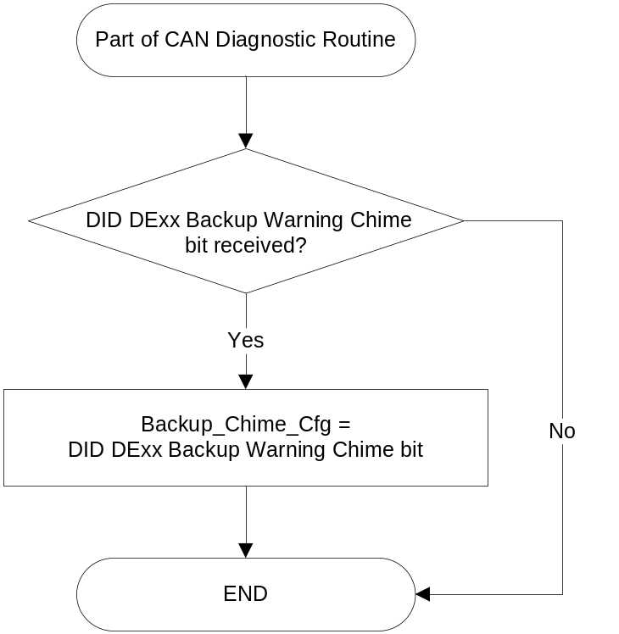

Table 1.2 Reverse Warning Chime State Matrix Table
Operational_Mode | Backup_Chime_Cfg | Backup_Chime_Timer | GearLvrPos_D_Actl  Signal | GearRvrse_D_Actl  Signal | Backup_Chime_Status_Flag
NORMAL | Enabled (0x1) | >= Backup_Chime  _Delay | Reverse (0x1) | X | True (0x1)
NORMAL | Enabled (0x1) | X | Missing as per 1.4.1 | ≠ Active_  confirmed (0x3) | False (0x0)
NORMAL | Enabled (0x1) | >= Backup_Chime  _Delay | X | Active_  confirmed (0x3) | True (0x1)
NORMAL | Enabled (0x1) | X | ≠ Reverse (0x1) | Missing as per 1.4.1 | False (0x0)
All other cases |  |  |  |  | False (0x0)

X = Don’t Care

Operation Description (supports algorithm flowchart /state diagram)

- The Backup_Chime_Cfg is set to ENABLED when the vehicle destination is Japan and DISABLED for all other countries. This feature will be set to DISABLED at the instrument cluster manufacturing plant. Cluster shall be configured via diagnostic at Vehicle Operations using DID DExx configuration. Backup_Chime_Cfg is set equal to the last value received in the diagnostic routine.
- Start Backup_Chime_Timer when GearLvr_Pos_D_Actl = 0x1 (reverse) or when GearRvrse_D_Actl = 0x3 (Active_confirmed). Stop and reset Backup_Chime_Timer when GearLvr_Pos_D_Actl ≠ 0x1 (reverse) and GearRvrse_D_Actl ≠ 0x3 (Active_confirmed).
- If GearRvrse_D_Actl is not in the program CAN dbc because the program does not have a manual transmission, then GearRvrse_D_Actl should not change and should never be equal to 0x3. Likewise, if GearLvr_Pos_D_Actl is not in the program CAN dbc because the program does not have aautomatic transmission, then GearLvr_Pos_D_Actl should not change and should never be equal to 0x1.

Function Safety Classification (EMC)

Class B

Memory Storage

Parameter Name | Description | Value at Battery connect | Value at  Module Wake-up
Backup_ Chime_Cfg | Configures cluster to allow reverse warning option (set to disable at cluster end of line) | Use Stored value | Use Stored value
GearLvrPos_D_Actl signal | Input signal for Gear Select on variants with auto trans | As per CAN dbc (0x0) | Do Not Init
GearRvrse_D_Actl signal | Input signal for Gear Select on variants with manual trans | As per CAN dbc (0x7) | Do Not Init
Backup_Chime_Status_Flag | Status flag used by the Chime Arbitrator to sound the backup warning chime. | False | Do Not Init
Operational_Mode | 4 State indicator for cluster operational mode | Limited | Limited or Normal or Crank
Note: "Do not init" = last known value

Parameter Name | Description | Range | Units | Resolution | Init Value
Backup_Chime_Delay | Time value used to delay the backup warning chime | 0-1023 | msec | 1 | 1000

Timer Name | Description | Value at Battery connect | Value at  Module Wake-up
Backup_Chime_Timer | Timer used when cluster is configured for the backup warning chime | 0 | 0

Prove Out

No

Error Handling

Missing Message Strategy

The signals will be declared missing as per the Diagnostics section of this SPSS.

DTCs states and history will be determined as per the Diagnostics section of this SPSS. If Backup_Chime_Cfg = Disabled (0x0), the cluster shall never log a missing message DTC due to this feature.

Diagnostics

Self Test

None

Engineering Test Mode

While in ETM the chime will behave as the State Matrix, however the chime connot be triggered through ETM directly. The last chime played is one of the ETM displays. Reference section “Dealer / Engineering Test Mode (ETM)”

Part II Performance

Supported Diagnostic Trouble Codes (DTCs)
DTCs shall be logged as per the diagnostic section of this SPSS.*

DTC | Description
C10100 C10000 | Lost communication with TCM PCM
C40182 | Invalid Data Received – No Update from PCM

* If the missed signal has an _UB signal, the NO Update DTC is to be logged.
Otherwise, the Lost Communication DTC is logged.

DID DExx Configuration
Block  Num | Block Description | Byte(s) | Bits | State: Description | "0" | "1" | Default | Comments/  Information
PACKETED BLOCKS
$xx | Option Content (B&A) | * | * | Backup Warning Chime | Disabled | Enabled | Enabled
*Byte and bit location to be identified in Part II Specification for this cluster

Reference Specification

EF-0033 SAFETY – CHIME ARBITRATOR
EF-0025 SAFETY – BACKUP WARNING CHIME
IS-0379 NORTH AMERICAN WARNINGS AND INDICATORS STRATEGY

Revision History
SPSS Module Revision History

Revision Level | Name | Change Description | Date
1.0 | V. Patel | Updated for CGEA 1.3 based on CGEA STSS v1.0  Section 1.2.2 – Deleted table referencing the HS-CAN message that contains the input signal. Deleted “ID” and “POS” columns from table 1.0  Section 1.3.5.1 – Added row for missing message action in table 1.1  Section 1.4 – Rewritten. Deleted references of specific missing message flags.  Section 1.5.3 – Deleted DTC logging criteria from the table. | 3/24/2010
2.0 | T. Cwik | Update to add a “reverse” signal for a manual transmission  Section 1.2.1 – Figure 1,0 – Added “GearRvrse_D_Actl” signal to process gear selection for manual transmission and changed to DEXX  Section 1.2.2 – Added Table 1.1  Section1.3.5.1 – Renumberd Table 1.1 to 1.2 and rewrote table to add “GearRvrse_D_Actl” column  Section 1.3.5.2 – Rewrote second tic point and added third tic point.  Section 1.3.5.4 – Added GearLvr_Pos_D_Actl and GearRvrse_D_Actl  Section 1.5.3 – Updated DE00 to DEXX. | 12/3/2012
2.1 | S. Watkins  M.Hakim | Corrected typos for DE00 to DExx in Figure1.1, Section 1.3.5.2, and section 1.5.3.  Removed Diagnostic DID and Diagnostic timer throughout the document.  Updated Table 1.2, Reverse Warning Chime State Matrix Table after removing the Diagnostic DID and Diagnostic timer.  Section 1.5.3  - Changed the DTC to be logged against the PCM, instead of the TCM.  - Added NO Update DTC. Added a note explaining which DTC to use.  Updated document header. | 8/9/2013

